Data Analyst Practical Exam Written Report

- Introduction
Our company, Fit.ly Tech, has been recently dealing with a loss in subscriber base. Leadership is focused on trying to limit the amount of churn. Our objective is to understand the main drivers of churn, with a focus on plan types, support activity, and user engagement. Based on the insights and patterns identified in the churn data, this analysis should lead to concrete business recommendations and potential key performance indicators to monitor in the future.
- Data Validation
We have been provided three datasets from different sources, each containing different types of data: account information, customer support, and user activity.
The account information dataset (source file “da_fitly_account_info.csv”) has 400 entries (rows) and 6 variables (columns). Data validation and cleaning steps were applied to each variable as follows:
- variable “customer_id” was modified to remove all letter characters in order to obtain a numeric only id value;
- variable “email” was left unchanged;
- variable “state” was validated to identify any unexpected values, but no unusual values were found; the variable was changed into a factor type to help with analysis;
- variable “plan” was validated, with no unusual values being found, and factorized to help with analysis;
- variable “plan_list_price” was validate and no unusual features were observed;
- variable “churn_status” was validated and it was observed NA values were used to represent negative churn status; therefore, NA values were replaced with “N” (as opposed to “Y” for positive churn status) and the variable was factorized in preparation for data analysis.
The customer support dataset (source file “"da_fitly_customer_support.csv") has 918 entries and 7 variables. Data validation and cleaning steps are described below as follows as follows:
- variable “ticket_time” was validated and left unchanged;
- variable “user_id” was validated and left unchanged;
- variable “channel” was validated and values set to “-” were replaced with “unknown” for clarity; the variable was changed into a factor;
- variable “topic” was validated and modified into a factor;
- variable “resolution_time_hours” was validated and no changes were necessary;
- variable “state” was left unchanged and ignored for analysis as its apparent meaning was not clear based on the information provided by Product Manager and Lead Engineer; it is important to note this variable is no equivalent with the “state” variable from the account information dataset;
- variable “comments” was left unchanged.
In addition, the dataset was validated for any duplicate entries. No apparent duplicates were found, so all initial 918 entries were considered valid.
The user activity dataset (source file "da_fitly_user_activity.csv") has 445 entries and 3 variables. Data validation and cleaning steps were performed as follows:
- variable “event_time” was validated and left unchanged;
- variable “user_id” was validated and left unchanged;
- variable “event_type” was validated and changed into a factor type.
- Exploratory Analysis
Plan Type Analysis
The account information dataset contains data for 400 customers, from which 114 have positive churn status representing about 28.5% of the customer base. Focusing on the plan types customers are subscribed to, there is a relatively equal distribution between all 4 plan tiers. The “Basic” plan is the most popular, followed by the “Free” plan, the “Enterprise” plan, and the “Pro” plan.
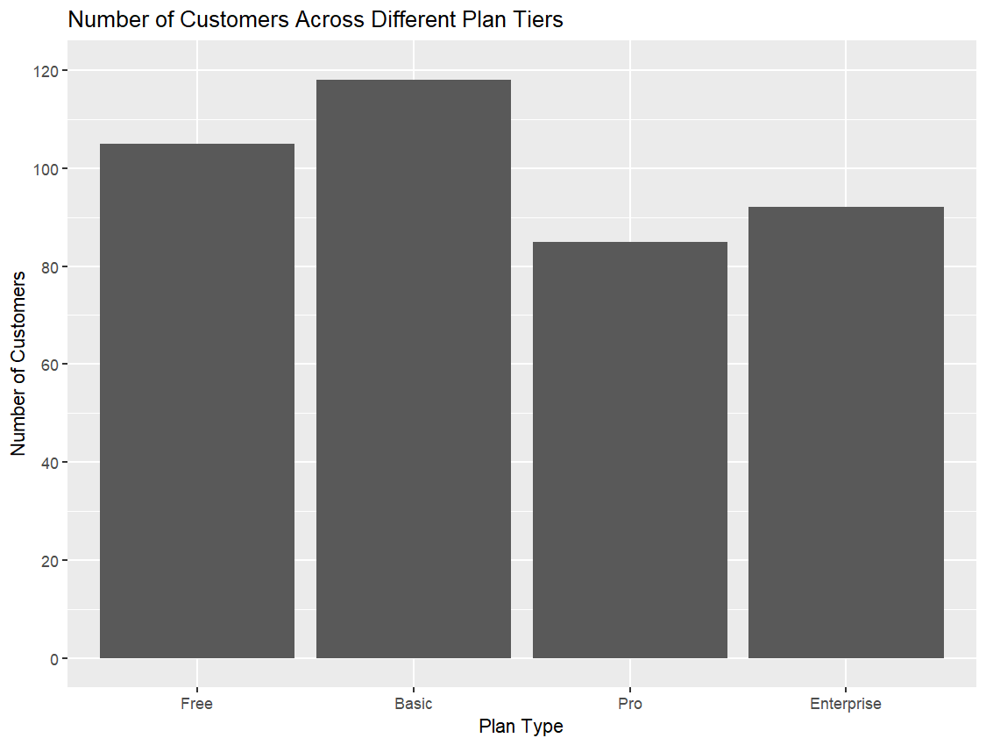
Price is the major factor that differentiates the 4 different plan tiers. Therefore, we have looked into calculating basic metrics for each plan, including the total number of customers, average plan price, median plan price, minimum/maximum plan price, and the average churn. The main observation is the variability in churn between different plans. While the mean churn over all plans is 28.5%, the “Free” plan has an outlier churn rate of 41%, while the three paid plans have similar churn rates between 22 and 26%. This suggests that we should analyze the different plan tiers based on whether they are a paid plan or not. From this point of view, the calculated overall churn rate for paid plans only is 24%, in comparison with the 41% for the free plan.
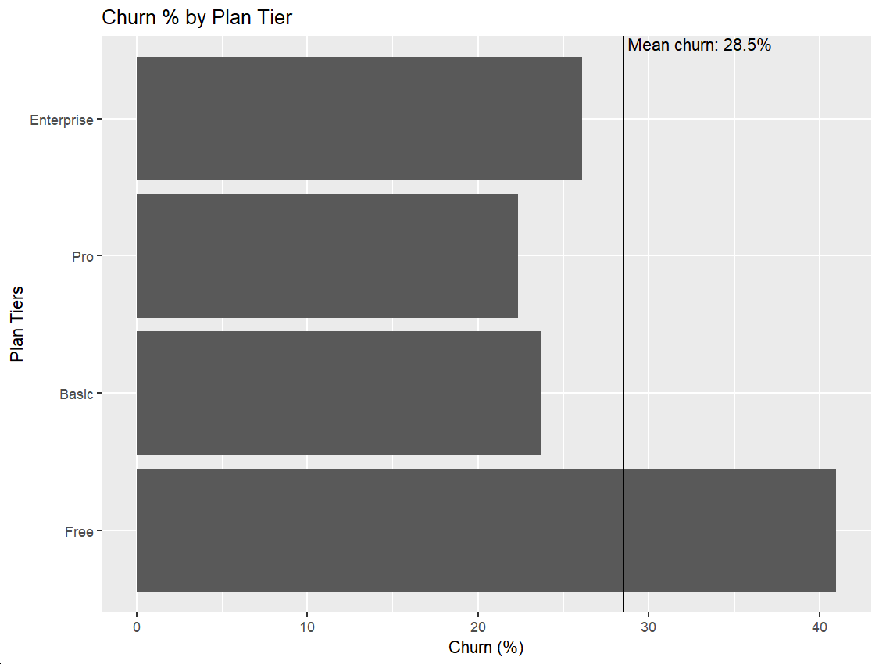
To try to get some insights specifically into the relationship between the paid plans and churn rate, we have calculated metrics separated for each plan and churn status. At a first look, there is no obvious difference based on churn for each paid plan tier. A visualization of plan price distributions based on churn status and plan confirms the overall lack of significant trends.
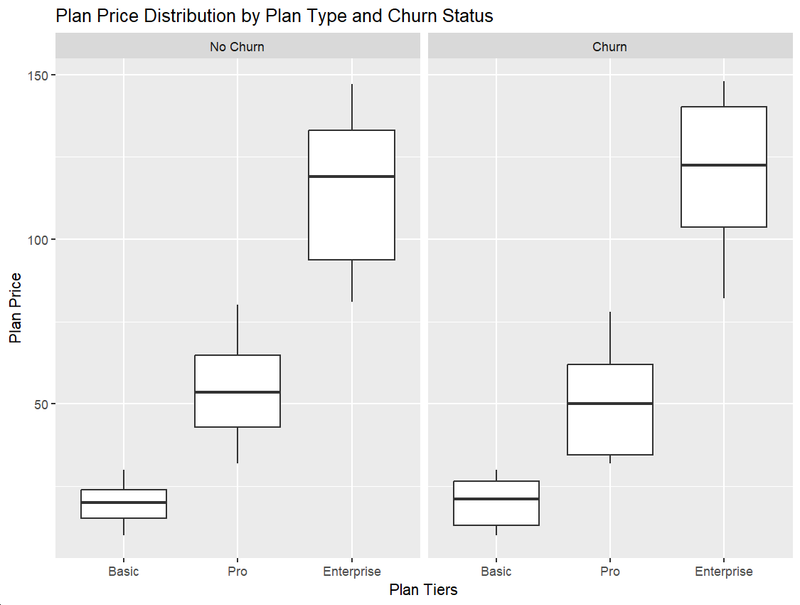
Support Activity Analysis
The support activity dataset contains 918 entries describing instances our customers submitted support tickets. At first glance, the resolution time associated with these tickets might been an important metric to study in more detail. Looking at the distribution of resolution times in hours, we observe that there are two distinct groups: a majority of tickets that are resolved in 12 hours or less, and a minority which take at least 13 hours to resolve and up to 32 hours. The difference between this two groups should be studied in the context of customer churn. However, these are individual tickets and individual customers might submit more than one. Therefore, we should first map these tickets to the specific customers by leveraging the information in the account information dataset.
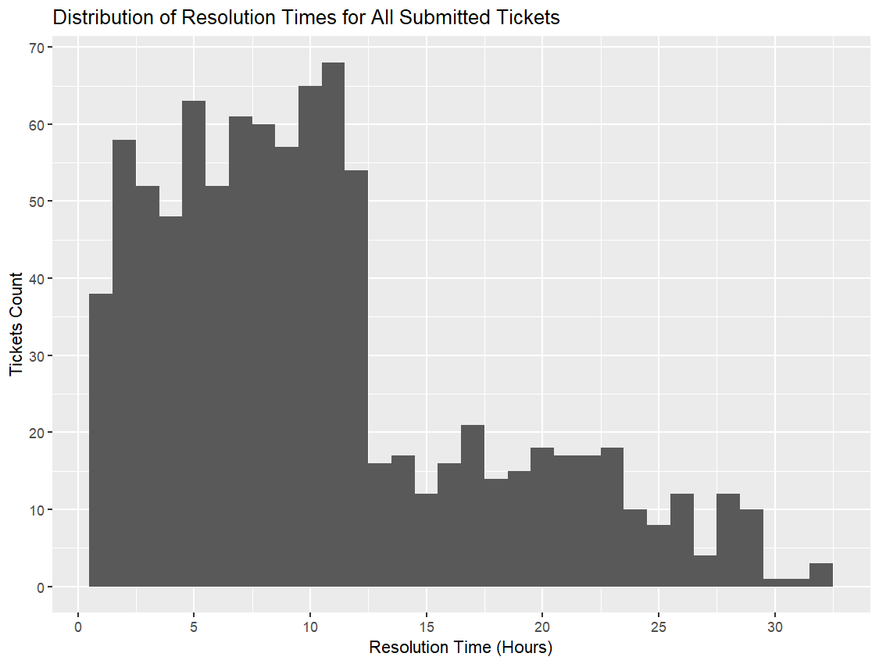
After mapping all the tickets to individual customers, we have associated descriptive metric of tickets resolution to each customer, including count of tickets submitted, mean and median resolution time, and minimum and maximum resolution time. Customers that have submitted no tickets would have a count of 0. From this new dataset, we can visualize a range of descriptive metrics. From the distribution of tickets count per user, we observe that the vast majority of users have submitted at least one ticket, with most of them submitting 1 to 4 tickets. If we compare the number of tickets submitted by churn status, there is no apparent difference between the two groups, meaning customers might not drop their subscription if they have to submit more support tickets.
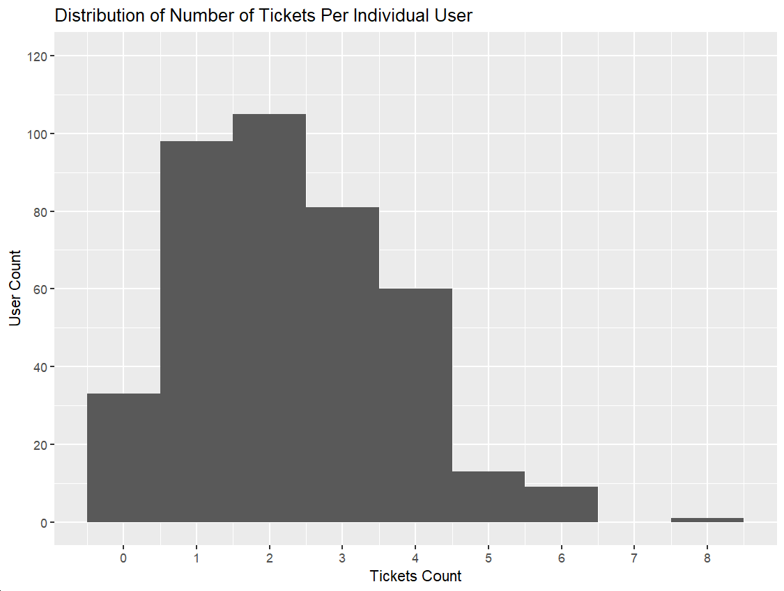
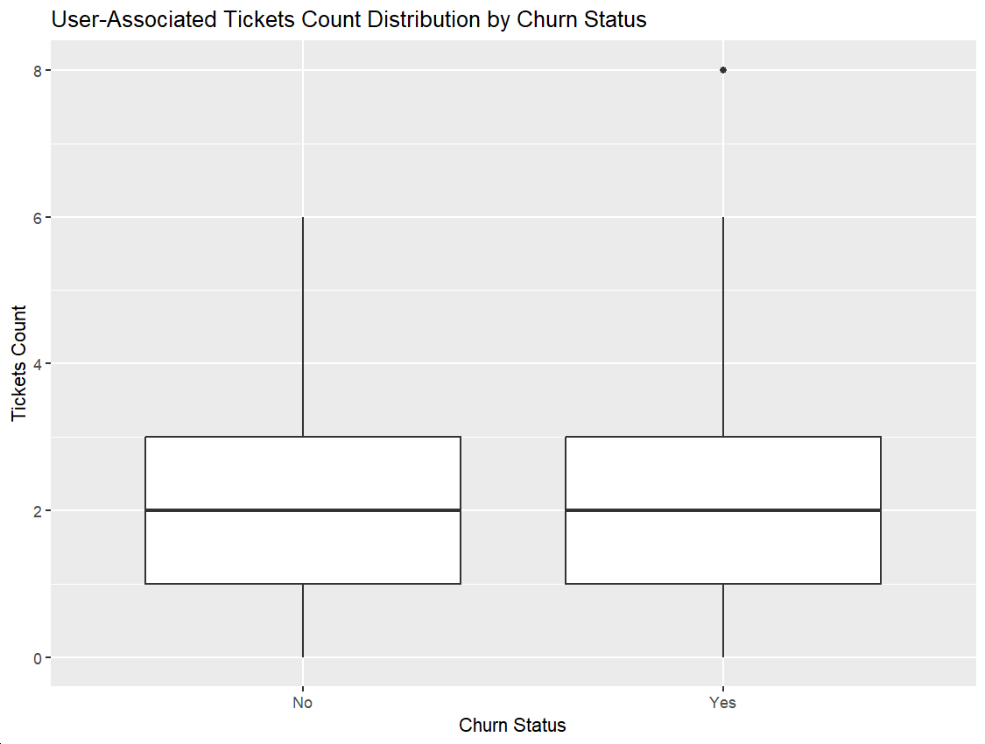
Next, we can look at the quality of customer service provided through the lens of resolution duration descriptive metrics. Because only about 33 out 400 users have submitted no tickets, we can specifically look at the customers that have submitted tickets and study the relationship between resolution descriptive metrics and churn status. Regardless of the descriptive metric compared, mean/median resolution or minimum/maximum resolution, the group containing churn-positive customers has longer resolution times.
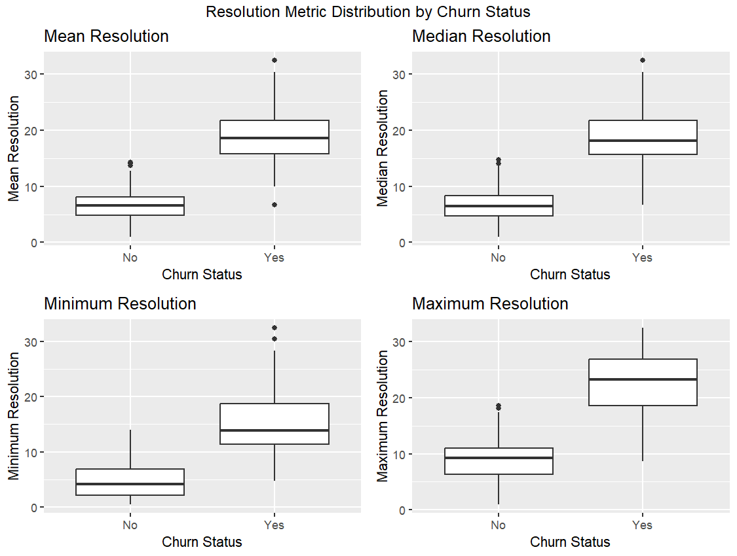
Back when we have looked at the distribution of resolution times for all tickets, we have highlighted that a majority of tickets are solved within 12 hours, but there is a minority of tickets that can take way longer to solve. Therefore, we consider here a threshold of 12 hours resolution time that separates the tickets in two distinct groups. We want to look at potential differences in churn between the two groups, but at individual user level, by associating a new boolean variable to each individual user based on the existence of at least one user-associated ticket that took longer than 12 hours to solve. Comparing the relative composition of the two churn status groups, we observe the vast majority of churn users, more than 90%, have had at least one ticket taking longer than 12 hours to solve. Meanwhile, only a minority of users with negative churn, less than 10%, have had one such support ticket. Overall, this analysis suggests it is important to reduce our customer support resolution times. Currently, 27.9% of the tickets part of the dataset have resolution times over 12 hours.
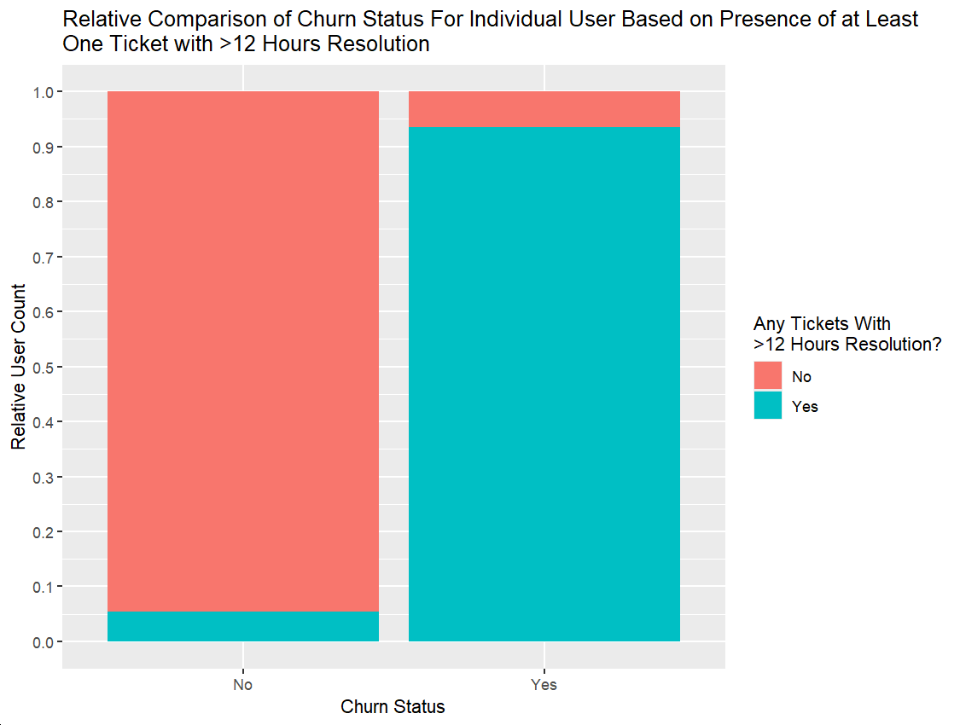
User Activity Analysis
The user activity dataset contains 445 entries describing types of activities individual users engaged in. All four types of activities are significantly represented, with at least 90 instances of each. Reading articles is the most popular at ~125 instances, followed by watching videos, tracking workouts, and share workouts respectively.
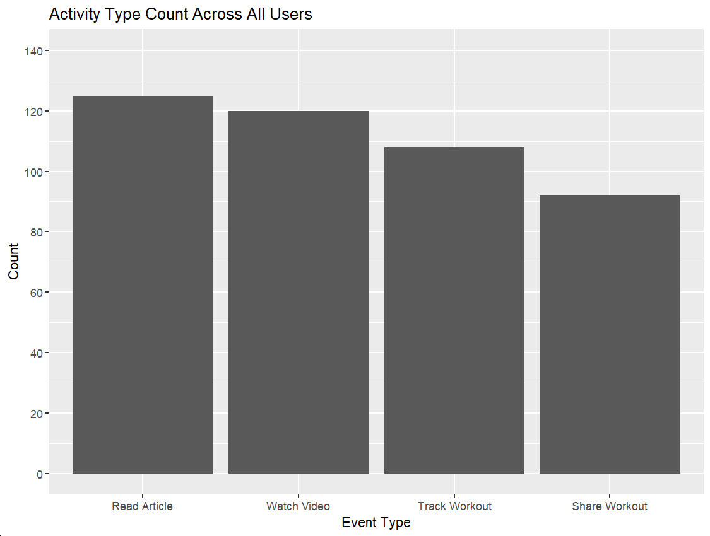
User engagement can be estimated by the count of activities they are performing, so we can count the number of activities at user level and combine the dataset with the user activity dataset, to ensure we can also analyze the users that did not perform any activity. Looking at the distribution of individual users by the number of activities engaged in, we observe that biggest group of users did not engaged in any activity, while the rest engaged in at least 1 and up to 5 activities. If we define a non-engaged user as having 0 activities and an engaged user as having at least 1 activity, our customer pool contains slightly more than 150 non-engaged users and almost 250 engaged users.
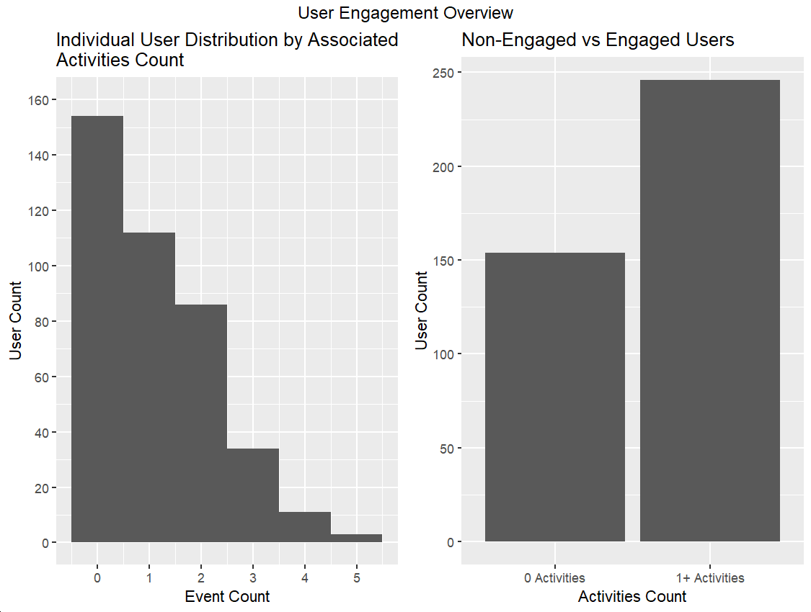
There are two ways we try to look at the relationship between user engagement and churn. First, we are using the above grouping into non-engaged and engaged users. We observe that almost 75% of positive churn users have not been involved in any activity in the 6 months period that the dataset covers. In comparison, only ~25% of negative churn users are considered non-engaged. Secondly, from a different perspective, we can look at the churn status for each group of users based on the activities count. We observe that more than 50% of users with 0 activities are churn positive, and churn rate generally decreases as users perform more activities. Overall, users involved in more activities are less likely to drop their subscription.
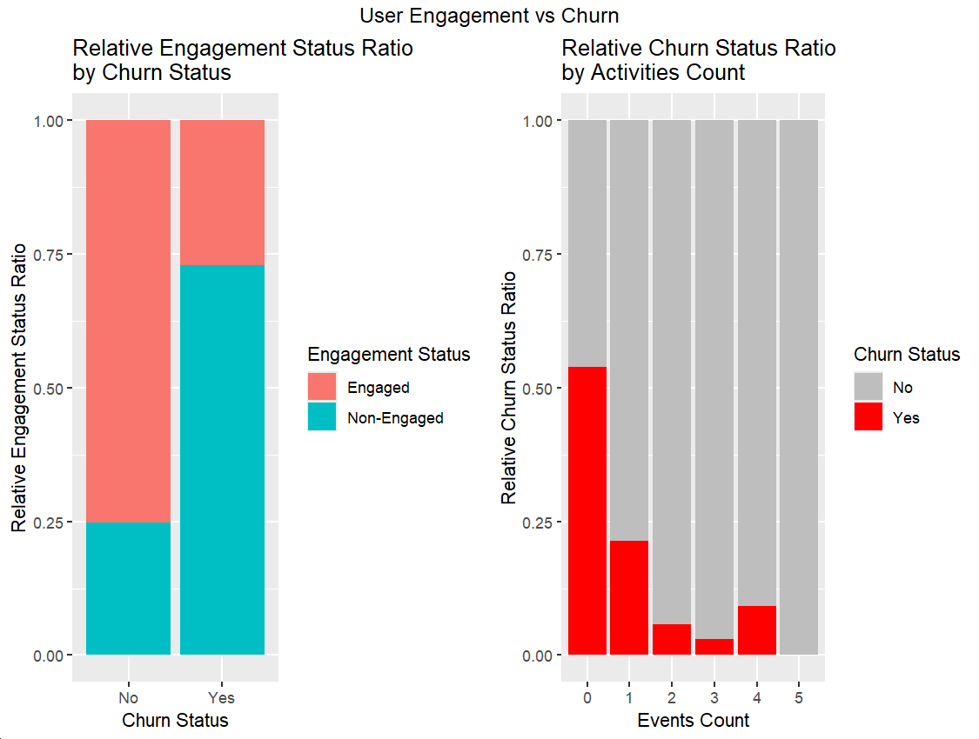
- Business Metrics
Based on the above data analysis and discussion of our insights, we can propose a few different metrics that we should follow in the future, each focused on different aspects of user plan choices, customer support, and customer engagement, and their relationship to user churn.
Firstly, we have observed that churn rates are different based on the choices of paid or free plans. It is likely that there a significant difference between the motivation of users on a free plan to continue using our app and that of users that already pay for their subscription and expect value for their investment in a paid plan. We suggest to monitor the different churn rates based on whether customers are on a free or paid plan. Based on the current data, free plan users have a 41% churn rate, while paid plan users have an average churn rate of 24.1%. Any strategies we implement should contribute to reducing the churn rates, but their effect might be of different magnitude for the two metric depending on specific motivations of the two customer groups.
Secondly, the analysis of the customer support data revealed that customers who submit a ticket that takes longer than 12 hours to solve are more likely to drop their subscription. We suggest to monitor the proportion of tickets with more than 12 hours resolution time. Based on the current available customer support data, 27.9% of the tickets take longer than 12 hours to solve. We would expect new approaches we implement in our customer service to reduce this metric.
Finally, the user activity dataset was analyzed to establish a relationship between user engagement and churn. The dataset covers a period of about 6 months. We have observed that users who engage in more activities are more likely to keep their subscription. Having users engaged in at least one activity every 6 months is recommended, but having more than two activities in the same period is ideal. We propose to monitor engagement by recording the proportion of users who are not engaged (meaning no activity in 6 month), or are engaged in either more than one or more than two activities. Based on the data available right now, we estimate the proportion of non-engaged users to be 38.5%, the proportion of users with at least one activity in 6 months to be 61.5%, and the proportion of users with at least two activities in 6 months to be 33.5%. Our expectation is that any business recommendation we implement has to reduce the non-engaged user metric and increase the one-activity and two-activities engagement metrics.
- Business Recommendations
In order to improve the business metric proposed, we have a few suggestions. We suggest that it is important to design our approach based on the different plan tiers that our customers use. Customers on a free plan are likely new adopters and need to be convinced it is worth using the app. On the other hand, customers on a paid plan are already more familiar with our app, but need convincing that their investment in a paid plan is still valuable. Customers on a free plan can be more extensively informed about app features they can use, and even be given access to paid features for a limited time to make them consider upgrading. Limited time discount upgrades for all customers can also be a good motivator to continue using the app or upgrade plans. It would be important that in the future we can survey what features our customers find useful between the different plan tiers to help build a data-driven strategy to conserve our customer base.
Regarding customer support aspects, we suggests prioritizing tickets based on the time since submission before they get close to the critical value of 12 hours period to resolution. There can be different priority tiers for each ticket, for example with low priority between 0 and 4 hours since ticket submission, medium for 4 to 8 hours, and critical for more than 8 hours.
Implementing new user engagement strategies can also help reduce churn. Users with no activities or up to one activity for the last 6 months can be nudged with recommendations to try new workouts or share their workouts, or be suggested media they can interact with, like articles and videos. It would be beneficial to get more information about our users and their preference for certain activities or even new activities they want to see implemented in the app. This would help us tailor our strategy in a data-driven manner, based on solid customer input.
This analysis represents a good starting point to study the drivers of churn for our customers. However, there is even more we can do by studying interactions between different factors, enriching these datasets with more information about our customers and their preferences and expectations, and in the future be able to establish importance rankings of different factors in driving churn and even be able to predict churn risks and take actions before users drop their subscription.

